RKEAB | IRTESP | SICHARE
_ _ k _ _ | p _ _ _ _ t | _ _ s _ _ e _
BIUVERRSD | ERKEEPHOUES | NECAAMMAR
_ u _ d _ i _ _ _ | _ _ u _ _ _ e e _ _ _ | _ _ _ _ _ a m _ _
UEUSMM  ARCTORU | DMSTUNA | OLFRIST
_ u _ _ _ m  c _ _ _ _ o _ | d u _ _ _ _ _ | _ _ _ _ _ s t
RSIE CEUNN ANGTE | NACIAMIG | RURTLCEE
_ n _ _ r _ _ _ e  _ _ _ _ _ | _ _ _ _ _ _ a n | _ e _ _ _ _ _ r
UTETPOSTIR | CWOLN | STEFISN UIRCTSNRTO
_ _ o _ t _ _ _ _ e | _ _ o _ _ | _ _ t _ _ _ _  i _ _ _ _ u _ _ _ r
WONIDW RLNAECE | ROTDRICE | BSKCOKETROR
_ i _ _ o _  _ _ _ _ n _ r | _ _ _ e _ _ o _ | s _ _ c k _ _ _ _ _ _

HLSCMTOIK | PMPI
_ _ c _ _ _ _ t _ | _ i _ _

SECCRET CODES
_ _ _ _ _ | _ _ _ _ _ _ | _ _ _ _ _ _ _
v  _ _ _ _ _ _ _ _ _ | _ _ _ _ _ _ _ _ _ _ _ | _ _ _ _ _ _ _ _ _
_ _ _ _ _ _  _ _ _ _ _ _ _ | _ _ _ _ _ _ _ | _ _ _ _ _ _ _
_ _ _ _ _ _ _ _ _ _ _ _ _ _ | _ _ _ _ _ _ _ _ | _ _ _ _ _ _ _ _
_ _ _ _ _ _ _ _ _ _ | _ _ _ _ _ | _ _ _ _ _ _ _  _ _ _ _ _ _ _ _ _ _
_ _ _ _ _ _  _ _ _ _ _ _ _ | _ _ _ _ _ _ _ _ | _ _ _ _ _ _ _ _ _ _ _ _
_ _ _ _ _ _ _ _ _ | _ _ _ _

a | b | c | d | e | f | g | h | i | j | k | l | m
n | o | p | q | r | s | t | u | v | w | x | y | z

Find 20 jobs hidden in the spiral.
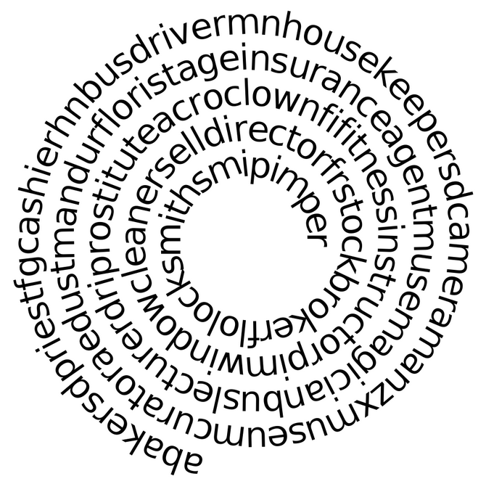
Which jobs hidden in the word cloud are better for men and which for women?
